智能合约 Greeter3

初始化账户中有10000META币

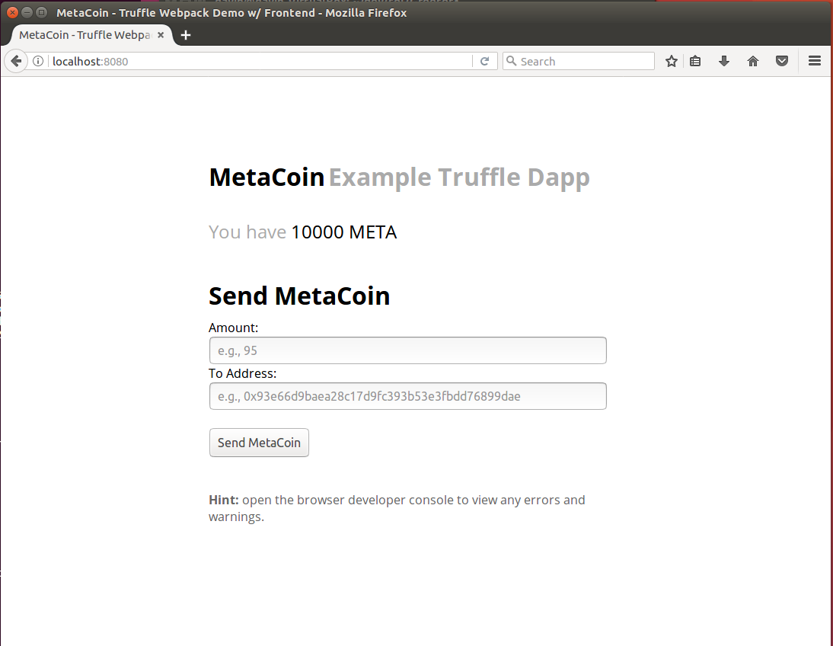

转账100个MetaCoin 到下图第二个测试用账户

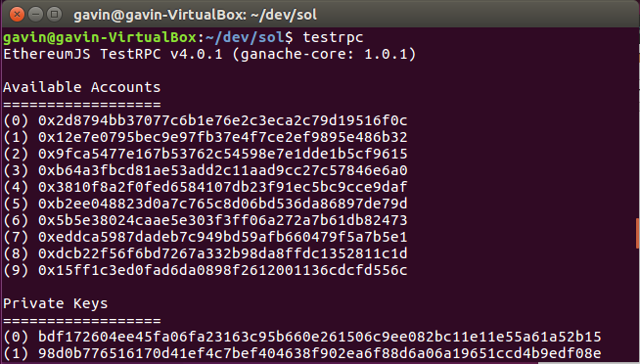

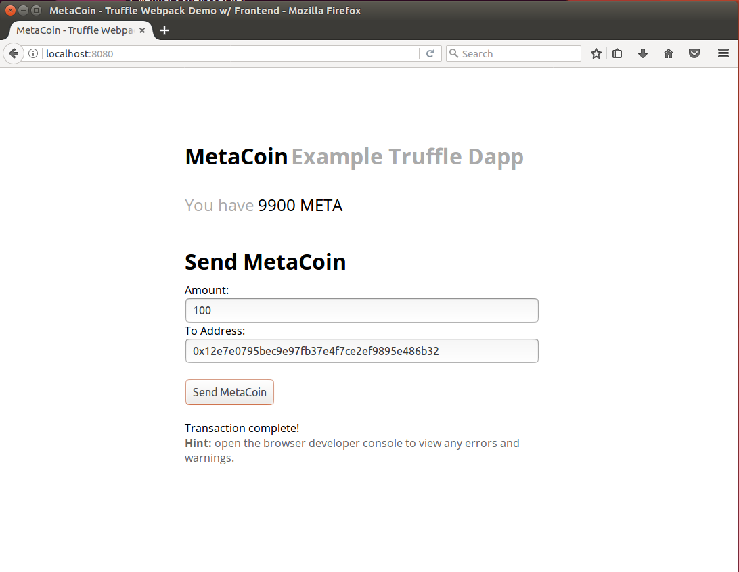

为这个转账交易生成了一个新的区块

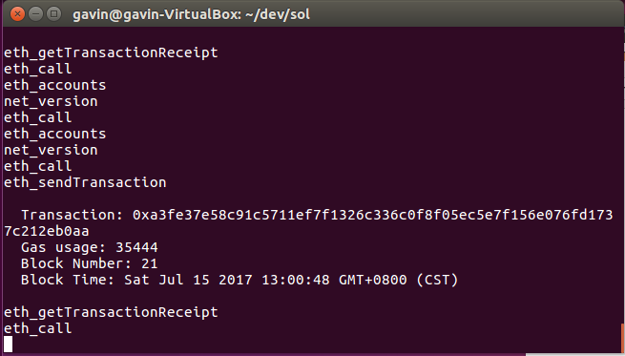

Geth account new生成3个新帐号， 密码都是123456

Address: {3f9381ee702c37c3b98e674b7680fea6de064d6b}

Address: {7ccbedeb7d07623ca48b69aa605d47a9b30f451b}

Address: {5623db3c432a6f9b011978e08ca8ba61c06e2028}

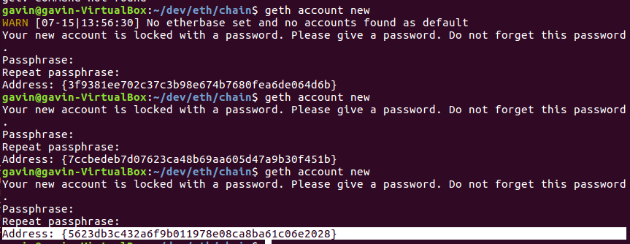

--

geth --rpc --rpcaddr="0.0.0.0" --rpccorsdomain="\*" --nodiscover --maxpeers '5' --datadir '~/dev/eth/chain/' --port 30303 --rpcapi "db,eth,net,web3" --networkid 15 --rpcport 8080 console

> eth.accounts

[]

> personal.newAccount("testaccount001")

"0xe57e6b74ecaf1b36f4dff48ac3e66a83e99dc8a2"

> INFO [07-15|15:07:51] New wallet appeared url=keystore:///home/gavin/dev/eth/… status=Locked

> personal.newAccount("testaccount002")

"0x7ff3604d943203489fa8385a7340903c21d72c00"

> INFO [07-15|15:11:19] New wallet appeared url=keystore:///home/gavin/dev/eth/… status=Locked

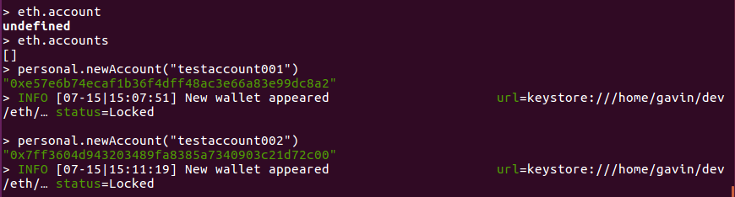

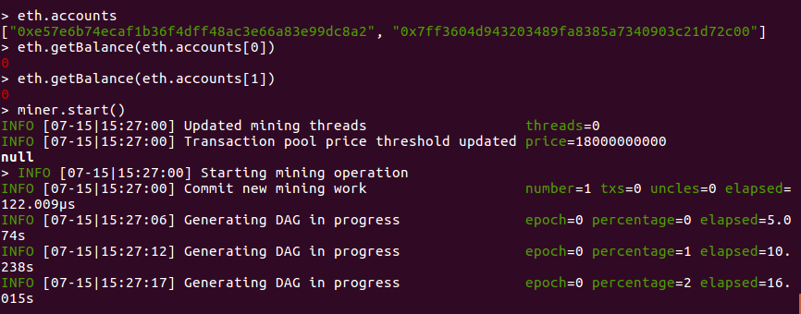

初始账户为零，开始采矿

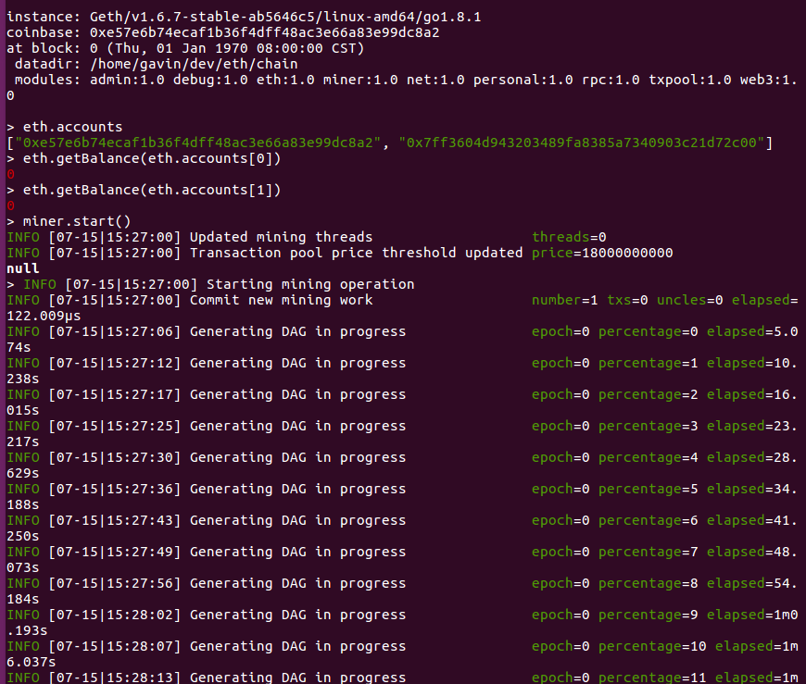

采到矿了

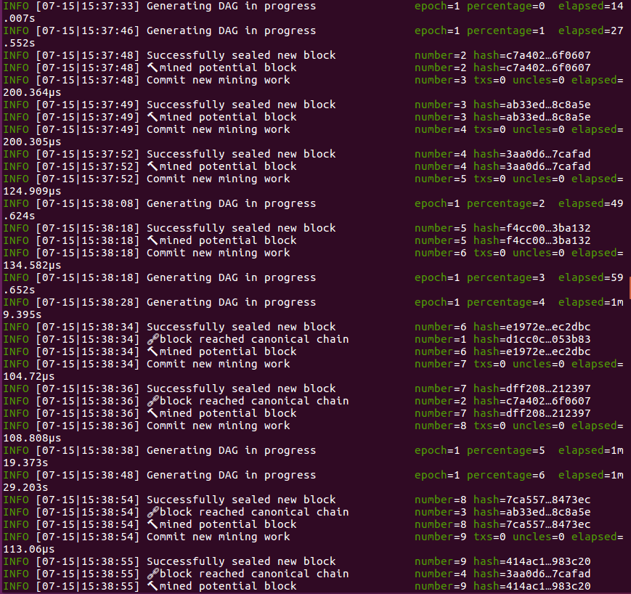

停止采矿，账户里有钱了

